MOCODO (MCD)

PROJECT: id, title, description, url, picture

DF, 1N PROJECT, ON SKIL

SKIL: id, title, description

CAROUSEL: id, picture, title, description

PROFIL: id, pictures, description

DOCUMENT: id, title, description, url, picture

MENTION: id, title, description

INFO: id, title, description, url

MAIL: id, firstname, lastname, email, number, description, date

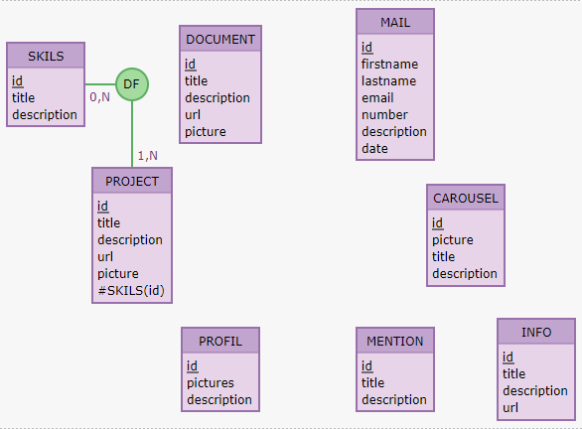

MLD

* Project
  + id INT NOT NULL
  + title TEXT NOT NULL
  + description TEXT NOT NULL
  + url TEXT NOT NULL
  + picture TEXT NOT NULL
  + #skil(id)
* Skil
  + id INT NOT NULL
  + title NOT NULL
  + description NOT NULL
* Carousel
  + id INT NOT NULL
  + picture TEXT NOT NULL
  + title TEXT NOT NULL
  + description TEXT NOT NULL
* Profil
  + id INT NOT NULL
  + picture TEXT NOT NULL
  + description TEXT NOT NULL
* Document
  + id INT NOT NULL
  + title TEXT NOT NULL
  + description TEXT NOT NULL
  + url TEXT NOT NULL
  + picture TEXT NOT NULL
* Mention
  + id INT NOT NULL
  + title TEXT NOT NULL
  + description TEXT NOT NULL
* Info
  + id INT NOT NULL
  + picture TEXT
  + description TEXT
  + url TEXT
* Mail
  + id INT NOT NUL
  + firstname TEXT NOT NULL
  + lastname TEXT NOT NULL
  + email TEXT NOT NULL
  + number INT NOT NULL
  + description TEXT NOT NULL
  + date DATE NOT NULL